**API TESTING**

**ADMIN**

**CREATE BOOKING**

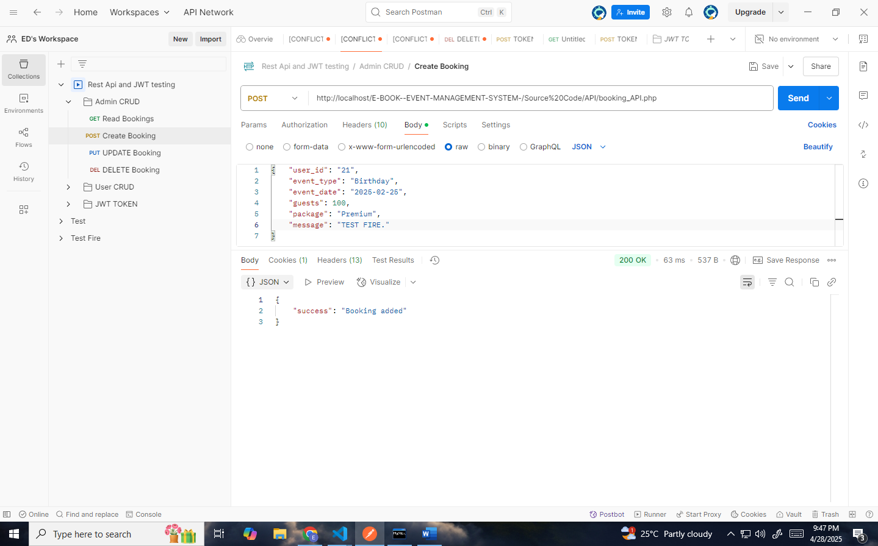



**READ BOOKING**

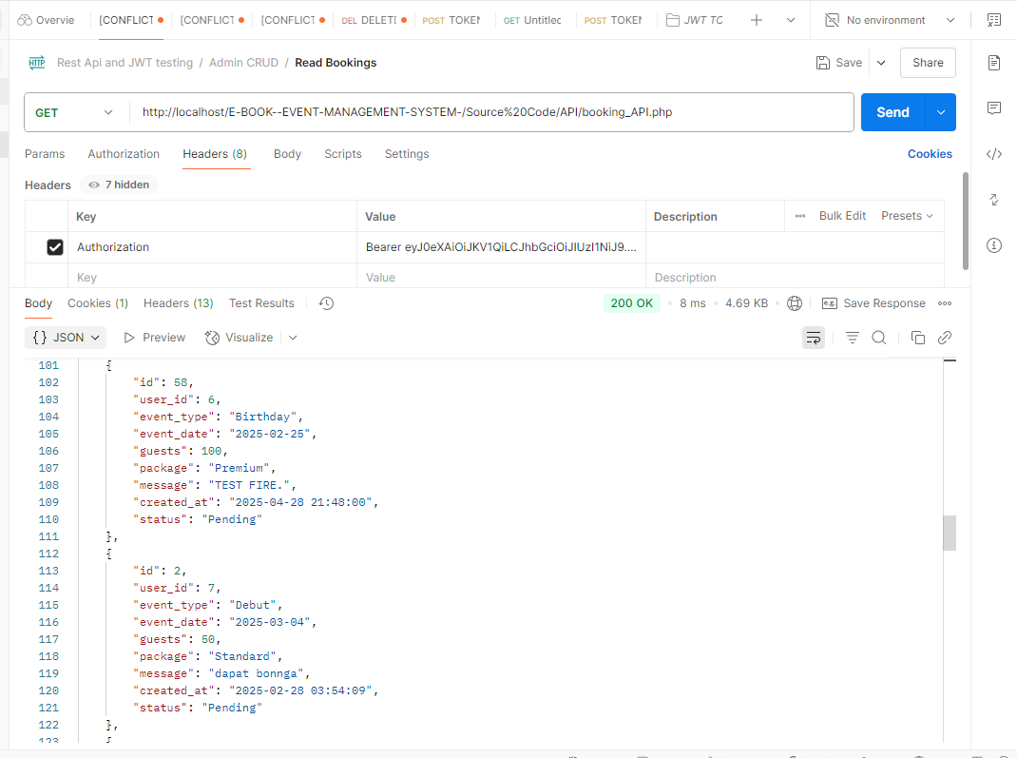

**UPDATE BOOKING   
**

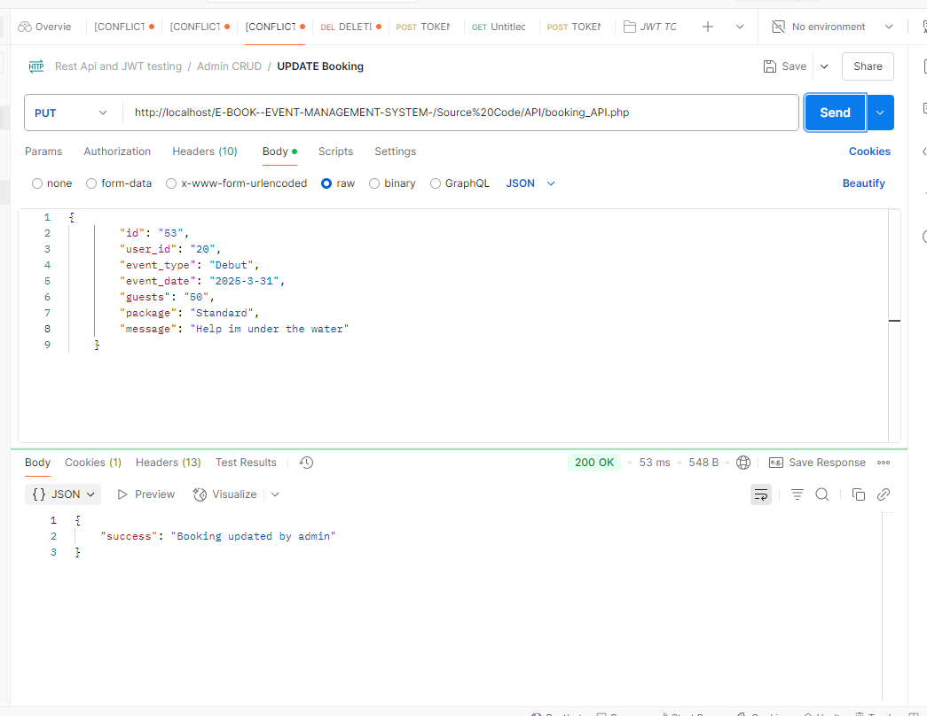



**DELETE BOOKING**



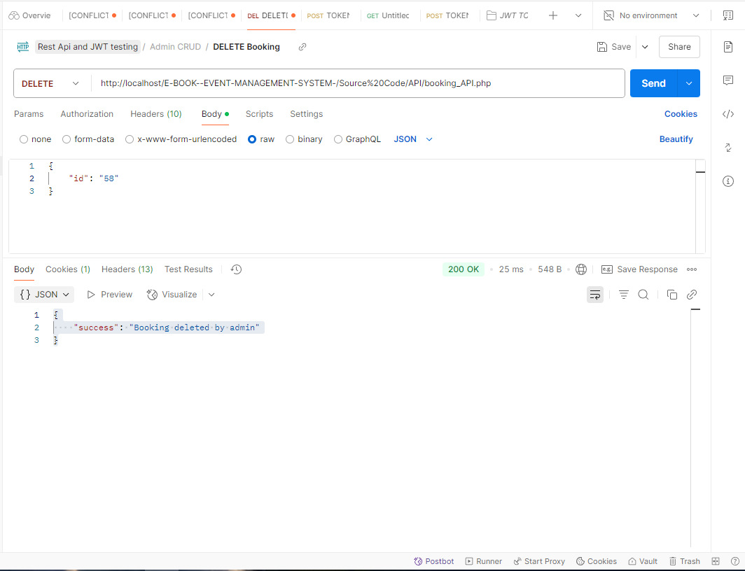



**USER**

**CREATE BOOKING**

**USED ACCOUNT FOR TESTING**



**IF THE USER CREATE BOOKINGS WITH OTHER ID**

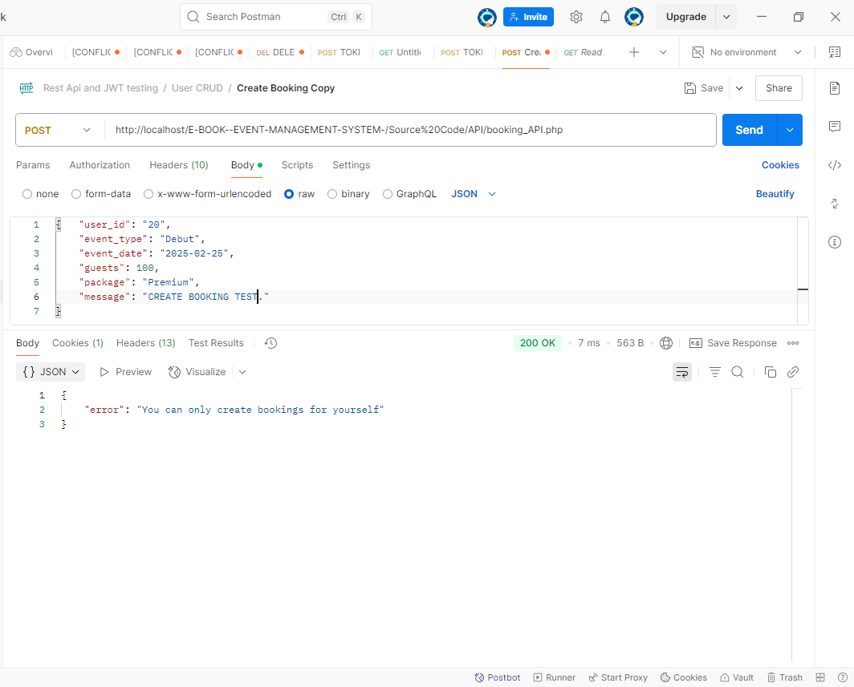

**IF THE USER USED THIER OWN ID**

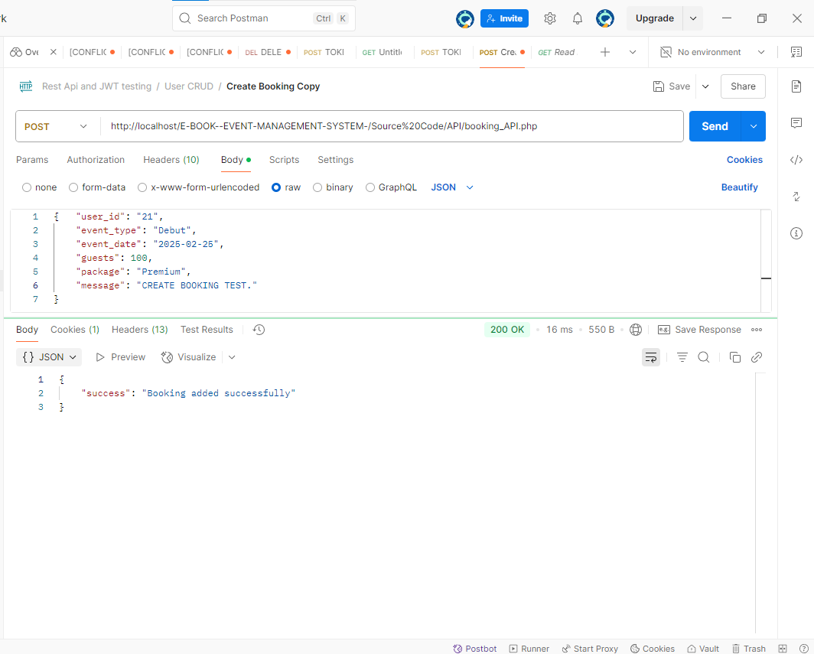



**READ BOOKING**

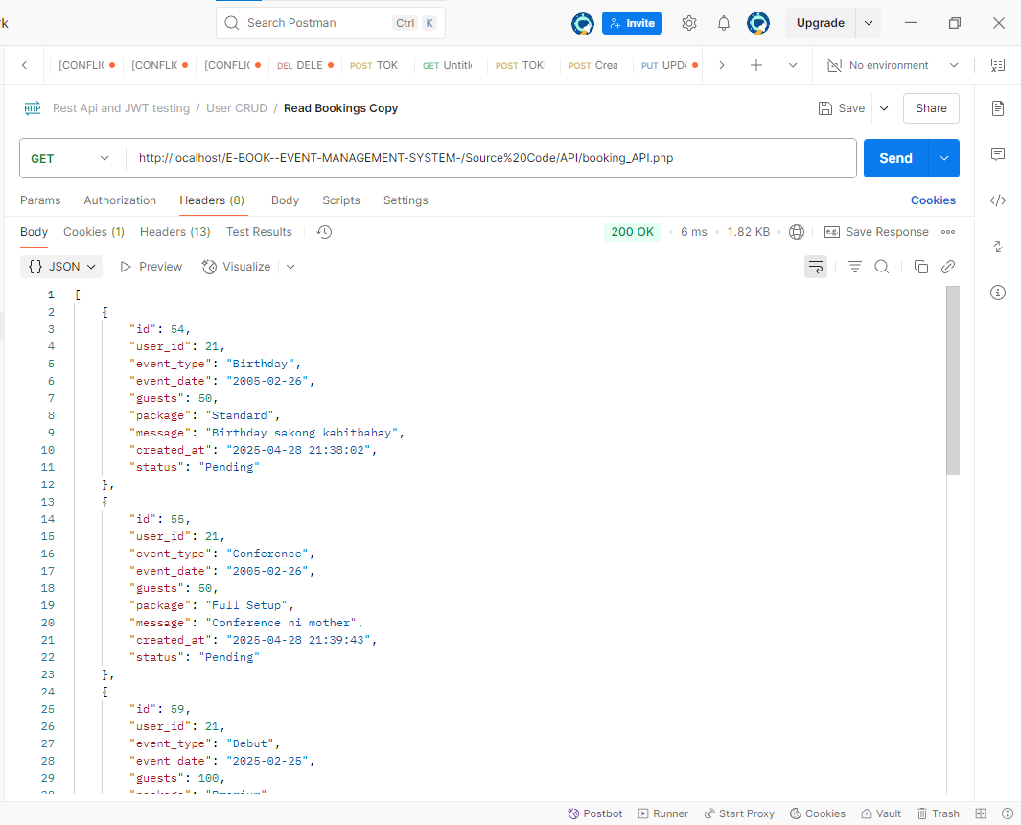**THE USERS CAN ONLY READ THEIR OWN BOOKINGS**

**UPDATE BOOKINGS**

**USER ONLY ALLOWED TO UPDATE THEIR OWN BOOKING**

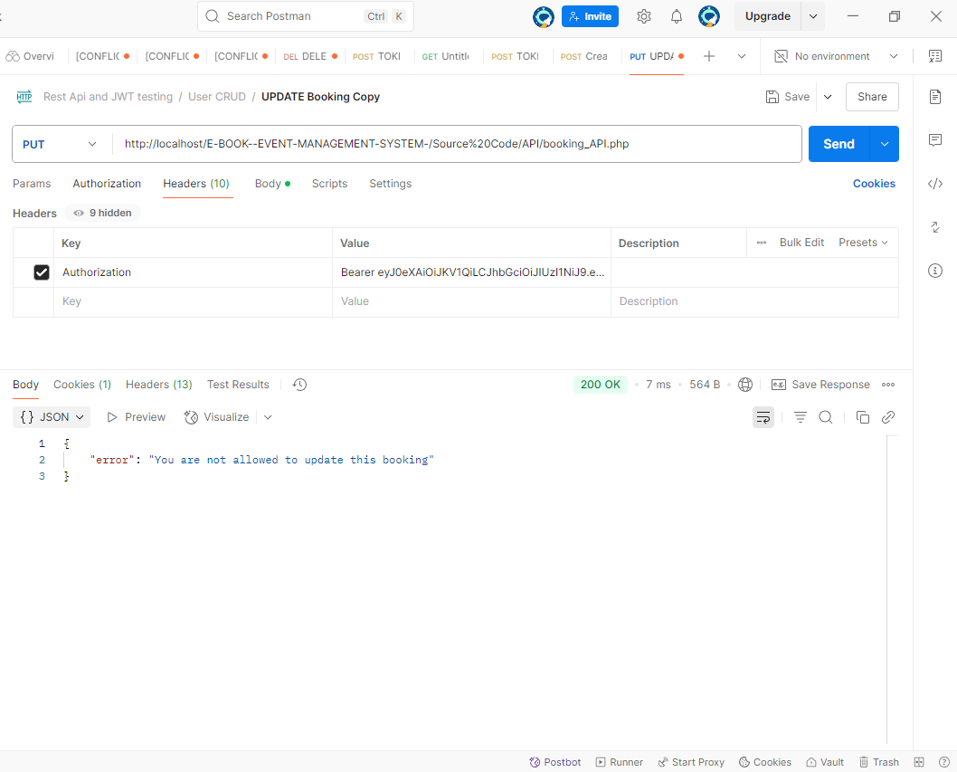



**AND IT WILL SEND AN EDIT REQUEST TO ADMIN**

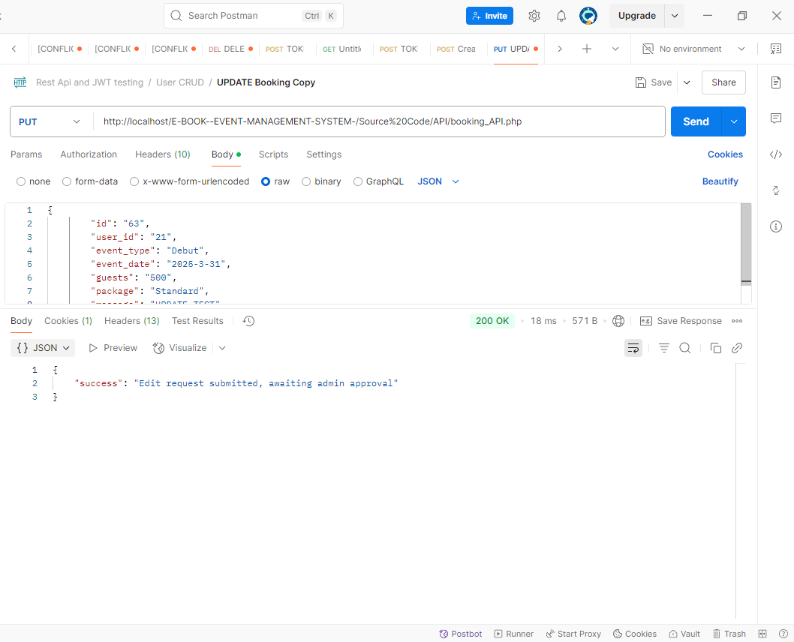

**DELETE BOOKING**

**USERS ONLY ALLOWED TO DELETE THEIR OWN BOOKING**

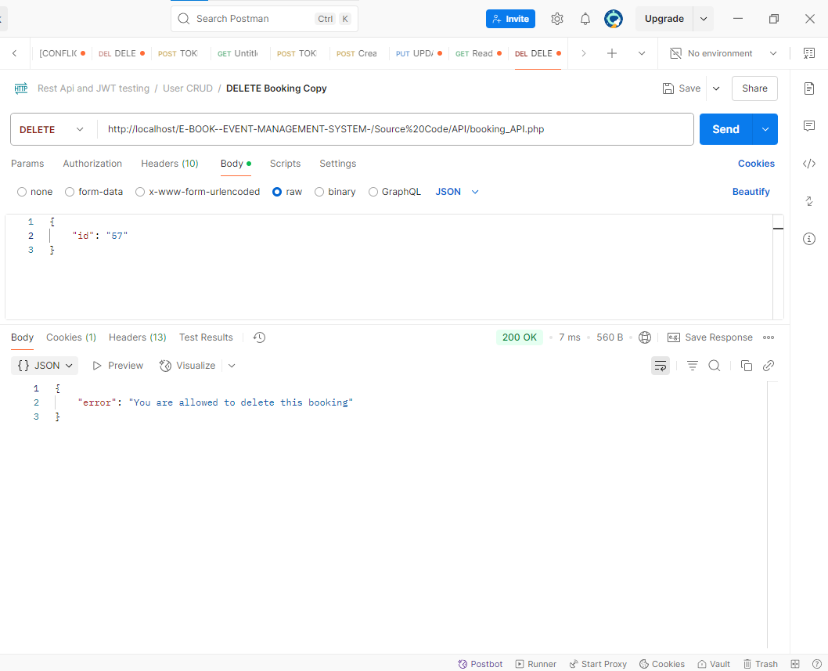



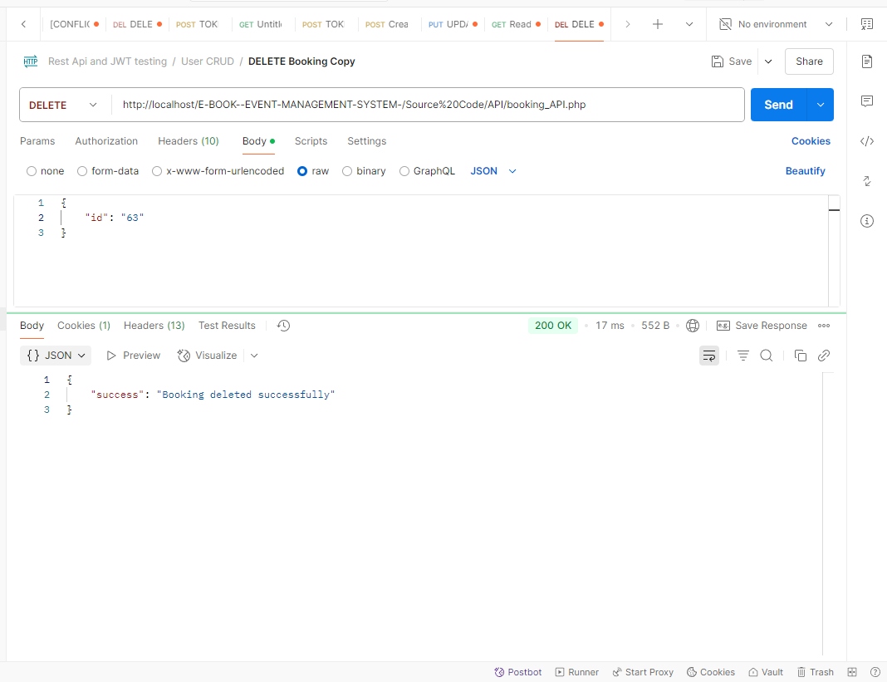



**JWT TOKEN**

